
 | 2026

COMPANY
PROFILE

PT SARANA ARTHA SOLUSI
Secure. Smart. Scalable.

www.sarthlutions.id
Cyber Security · Software Development · AI Agent Development · IT Procurement

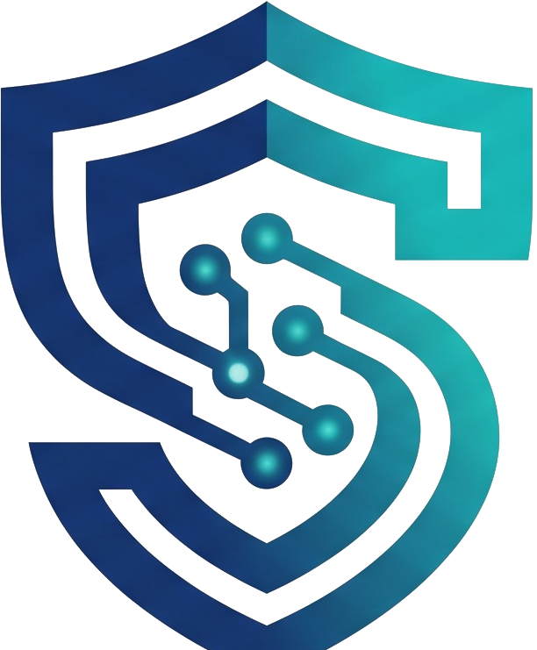 SARTHLUTIONS | COMPANY PROFILE · 2026

01 / ABOUT US
About the Company

PT Sarana Artha Solusi — known as Sarthlutions — is an Indonesian technology company that helps organizations build, secure, and scale their digital systems.  We bring together offensive security expertise, modern software engineering, and applied artificial intelligence, so that every solution we deliver is not only functional, but resilient and ready for what comes next.  From hardening critical infrastructure and building intelligent business applications to sourcing the right technology, we work as a long-term partner — not simply a vendor.
  50+
  PROJECTS DELIVERED
  30+
  ORGANIZATIONS SERVED
  15+
  CERTIFIED PROFESSIONALS

  Security First  Every system we touch is designed to withstand real-world attacks. |  | 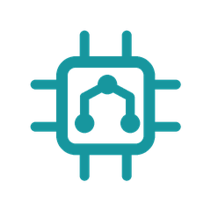  Technology Forward  We adopt automation and AI where it creates measurable value. |  |   Partnership Driven  We stay involved long after go-live, not only until handover.
SARTHLUTIONS | COMPANY PROFILE · 2026

02 / VISION, MISSION & VALUES
Vision, Mission
and Values

Vision  To become a trusted technology partner that makes Indonesia's digital ecosystem safer, smarter, and more competitive. |  | Mission  — Deliver secure, reliable, and measurable technology solutions.  — Make advanced security and AI capabilities accessible to organizations of every size.  — Build long-term partnerships grounded in integrity and transparency.  — Grow local talent that can compete at an international standard.

Our Values

01  Integrity  We say what we find, and we find what matters. |  | 02  Security First  Security is a starting requirement, never an add-on. |  | 03  Innovation  We keep pace with technology so our clients do not have to. |  | 04  Collaboration  We work inside your team, not across a wall. |  | 05  Real Impact  Success is measured by outcomes, not deliverables.
SARTHLUTIONS | COMPANY PROFILE · 2026

03 / OUR SERVICES
Our Services

Four connected capabilities that cover the full lifecycle of a secure digital system — from protecting what you already run to building what comes next.

Cyber Security  Penetration testing, vulnerability assessment, security hardening, and incident response — we find weaknesses before attackers do and help you close them for good. |  |   Software Development  Custom web, mobile, and enterprise systems built to scale, from requirement discovery and design through development, deployment, and long-term support.
AI Agent Development  Intelligent agents and automation workflows that plug into your existing systems to cut manual work, speed up decisions, and unlock the data you already own. |  |   IT Procurement  Sourcing, licensing, and delivery of hardware, software, and infrastructure with vendor-neutral advice, transparent pricing, and support through implementation.
SARTHLUTIONS | COMPANY PROFILE · 2026

04 / OUR APPROACH
How We Work

A structured engagement model that keeps every project predictable, transparent, and accountable.

01 |  | Discover  We map your business goals, technical landscape, and risk exposure.
02 |  | Design  We architect a solution that fits your budget, timeline, and compliance needs.
03 |  | Develop  Our engineers build and test to a defined quality and security standard.
04 |  | Deliver  We implement, migrate, document, and train your team for adoption.
05 |  | Optimize  We monitor, review, and improve continuously after go-live.

SARTHLUTIONS | COMPANY PROFILE · 2026

05 / WHY CHOOSE US
Why Organizations
Choose Sarthlutions

We are not just a technology provider — we are your partner in building systems that stay safe as they grow.

  Security-First Engineering  Security is embedded from the first line of code, not bolted on before launch. |  |   Certified & Experienced Team  Practitioners with recognized security and engineering certifications behind every project.
  End-to-End Delivery  One accountable partner from assessment and build to procurement and support. |  |   Measurable Impact  Clear metrics, honest reporting, and outcomes you can present to your board.
SARTHLUTIONS | COMPANY PROFILE · 2026

06 / OUR CLIENTS
Our Clients —
Software Development

Organizations we have supported in designing, building, and modernizing their digital systems.

[ Client Name ]  [ Project / Scope ] |  | [ Client Name ]  [ Project / Scope ] |  | [ Client Name ]  [ Project / Scope ]
  [ CLIENT LOGO ]
  [ CLIENT LOGO ]
  [ CLIENT LOGO ]
[ Client Name ]  [ Project / Scope ] |  | [ Client Name ]  [ Project / Scope ] |  | [ Client Name ]  [ Project / Scope ]
  [ CLIENT LOGO ]
  [ CLIENT LOGO ]
  [ CLIENT LOGO ]
[ Client Name ]  [ Project / Scope ] |  | [ Client Name ]  [ Project / Scope ] |  | [ Client Name ]  [ Project / Scope ]
  [ CLIENT LOGO ]
  [ CLIENT LOGO ]
  [ CLIENT LOGO ]

Replace each placeholder with the client logo, organization name, and a short description of the delivered scope.
SARTHLUTIONS | COMPANY PROFILE · 2026

07 / OUR CLIENTS
Our Clients —
Penetration Testing

Organizations that trusted us to test, harden, and validate the security of their systems.

[ Client Name ]  [ Assessment Scope ] |  | [ Client Name ]  [ Assessment Scope ] |  | [ Client Name ]  [ Assessment Scope ]
  [ CLIENT LOGO ]
  [ CLIENT LOGO ]
  [ CLIENT LOGO ]
[ Client Name ]  [ Assessment Scope ] |  | [ Client Name ]  [ Assessment Scope ] |  | [ Client Name ]  [ Assessment Scope ]
  [ CLIENT LOGO ]
  [ CLIENT LOGO ]
  [ CLIENT LOGO ]
[ Client Name ]  [ Assessment Scope ] |  | [ Client Name ]  [ Assessment Scope ] |  | [ Client Name ]  [ Assessment Scope ]
  [ CLIENT LOGO ]
  [ CLIENT LOGO ]
  [ CLIENT LOGO ]

Replace each placeholder with the client logo, organization name, and the type of assessment performed (web, mobile, network, red team).
SARTHLUTIONS | COMPANY PROFILE · 2026

08 / TECHNOLOGY & COMPETENCIES
Technology
& Competencies

Modern tooling and established standards, chosen for what the problem needs — not for what is fashionable.

Web & Mobile |  | Cloud & DevOps |  | Data & Analytics
AI & Automation |  | Offensive Security |  | Network & Infrastructure
API & Integration |  | Identity & Access |  | Compliance & Audit

Standards & Frameworks We Follow
OWASP ASVS · OWASP Top 10 · NIST CSF · PTES · ISO/IEC 27001 · Indonesian Personal Data Protection Law (UU PDP)
SARTHLUTIONS | COMPANY PROFILE · 2026

READY WHEN YOU ARE
READY TO SECURE
AND SCALE YOUR
ORGANIZATION?

Let us discuss your challenges and design the right solution — from the first assessment through to delivery and continuous improvement.

Schedule a consultation: contact@sarthlutions.id
SARTHLUTIONS | COMPANY PROFILE · 2026

CONTACT US
Let's Talk

EMAIL
contact@sarthlutions.id
WEBSITE
www.sarthlutions.id
OFFICE
South Jakarta, DKI Jakarta


PT SARANA ARTHA SOLUSI
Secure. Smart. Scalable.

